SCHOOL NEWSLETTER | December 2022 EDITION
WALSH
ELEMENTARY SCHOOL
HAGERSVILLE

From the Principal’s Desk
I can’t believe it is December already, and almost the end of 2022 as well!
It has been a pleasure to watch our students grow academically, socially and emotionally over the last few months.
On an instructional note, we are fortunate to have Mrs. Swyers as our school math coach this year. She will be spending time with our primary teachers and in our primary classes working on the math learning continuum, math talks and ‘just in time’ math games. This work is researched based.

On behalf of the staff here at HES, we wish everyone a safe and joyful holiday break!
Kathy Ricker

Student Illness
We have experienced a high amount of student illness this year.
If your child is experiencing symptoms, or not feeling well, please make arrangements for them to remain at home, and inform the school of their absence. We hope that these bugs will start to subside soon!
School Wide Days to Note
November 30th | Intermediate Boy’s Volleyball Tournament
December 6th | Intermediate Girl’s Volleyball Tournament
Dec. 1, 8, 15, 22 | Pizza Days
December 13th | Primary Holiday Performance and Junior/Intermediate Craft Night 6:30 – 8:00 pm.  Primary Holiday Performance, 1:45 afternoon performance
December 9 | Hat and Mittens Day
December 16 | Junior Volleyball Tournament
December 19 | Red and Green Day
December 20 | Hat and Headgear Day
December 21 | Holiday Sweater Day
December 22 | Be a Christmas Tree Day
December 23 | Christmas PJ Day
December 24-January 8th | HAPPY HOLIDAYS!!

Giving Tree
We have a lot of things happening at HES to spread holiday cheer, including our Giving Tree. Please consider helping us spread the joy!


Our tree is looking cozier everyday with contributions of socks, mittens, hats, etc.! We are also looking for non-perishable canned food donations. We will be collecting until December 14, after which we will be donating all goods to families in need.

Our New Portable  Our new portable is in place behind the school. Contractors have been working daily to get is set up and ready for classroom use. Mr. Telfer’s Grade 6/7 class will be calling the portable their new home. Very exciting!  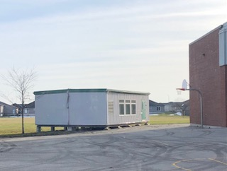  Healthy Snack Program  The Snack Program is in full swing and we would like to thank the hard work of Ms. Kruis-Daily’s class and the financial support of Haldimand-Norfolk Reach’s Child Nutrition Network.  In order to maintain this program the school needs to raise 15% of the total donation from REACH (approx. $2000). You can go to SchoolCash Online to make donations to the valuable program.  Please consider supporting this worthy endeavour.  Spirit day results so far by Classroom  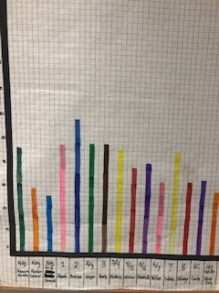 | Lunchtime Supervisors  We continue to need Lunchtime Supervisors. There is flexibility in which days and times help is needed. If you are interested, please call the school to speak to Mrs. Ricker. Thanks in advance!  Student Drop-off and Pick-up  Parents please remember that the front of the school is our bus route so unfortunately you are  not able to drive in or park there during  arrival and dismissal times.  Also, please make sure that you are not blocking driveways of our neighbours. Please be respectful and safe and park only in designated parking areas when dropping off or picking up your student.  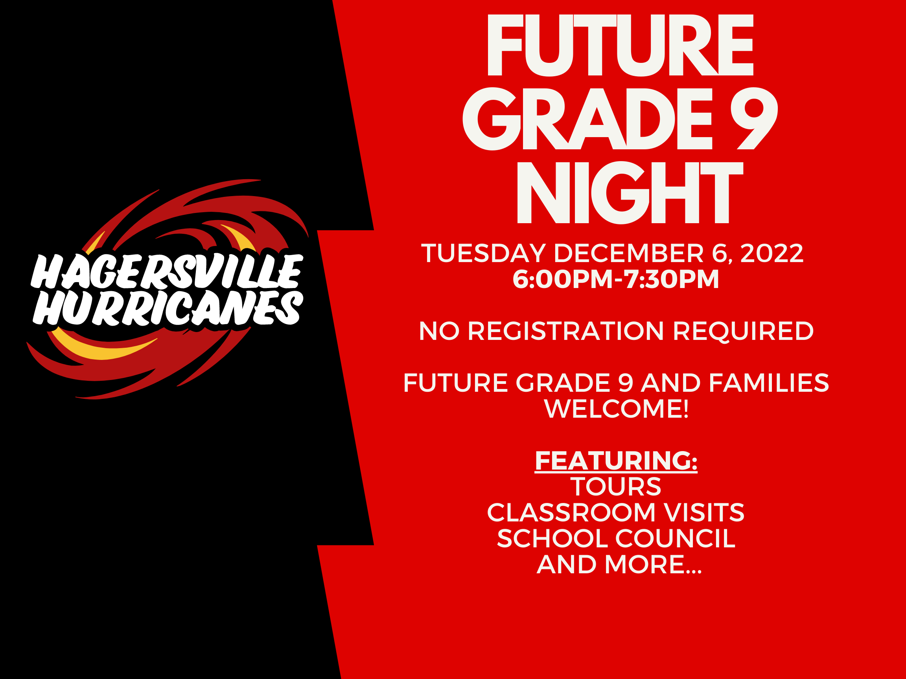  Self-Regulation Parent Resource  Self-Regulation  HES staff have received professional learning about  Dr. Shanker’s model of Self-Regulation to support student learning, belonging and well-being.  Please see the resources below for parents that will help you understand the work we are doing here and also how self-reg might look at home…https://self-reg.ca/parents/  