

October 2018
Grandview Grizzlies
68 North Park St. N3R 4J9
Brantford, ON 519 752- 2610
Website: http://www.granderie.ca/schools/grandview

Principal’s Message:

As September draws to a close, it is hard to believe that we have been back to school for an entire month! Thank you to our staff, students, and families for helping us get the 2018-2019 school year off to a great start! It was great to meet so many of our families at our annual Meet the Teacher open house. As we look forward to the month of October, we are reminded of the many exciting events happening in our families, our community, and at our school. From sporting events to outings and visitors, our students will be busy learning from many enriching opportunities.

We will keep you informed of what's happening at our school through monthly
newsletters and our school website. http://www.granderie.ca/schools/grandview
There you will find links to school news and transportation. We also have a Twitter feed on our website if you would like to see some of the activities at the school. The address for the Twitter feed is @GrandviewGrizz

ATTENDANCE ROUTINES
Student Attendance is checked twice daily. Unless you, as the parent/guardian, have
contacted the school to explain that your child will be late or absent, the school office
is required by Board Policy to verify all absentees. For your convenience, an
answering machine is attached to the school’s incoming phone line and messages can
be left during the evening and night time hours to inform the school if your child will
be absent. Please state your child’s name and the teacher’s name of his/her class when
leaving your message.

School Council Start-up Event – October 18
School Councils play a vital role in the education of all Grand Erie students through their work to promote and improve student achievement and school performance as well as their leadership in encouraging parent involvement at schools and learning at home. All Grand Erie Schools must have a school council. Additionally, school council elections must be held within the first 30 days of the school year.

Grand Erie’s annual School Council Start-up, sponsored by the Grand Erie Parent Involvement Committee (GEPIC), takes place Thursday, October 18 from 6-8 p.m. at Waterford District High School. All School Council Chairs, Home and School Associations Chairs or Parent Teacher Associations Chairs as well as their members are urged to attend. The School Council Start-up is an important event for all School Council Chairs as key information is provided and great ideas are shared.
For details on the event and to RSVP visit: https://bit.ly/2MRCjqa

Bus Cancellation/School Closure
In the event of bus delays, cancellations or school closures:
Visit the GEDSB website: http://www.granderie.ca or http://www.stsbhn.ca/

Grandview School is located in ZONE 4.

Grandview Public School News

A Few Important Notes:

Upcoming Dates
October 2 PA Day
October 3 Immunization Grade 7 & 8
October 5 Picture Day
October 8 No School/Thanksgiving Holiday
October 9 Bus Evacuation
October 24 Dress Purple Day for Child Abuse Prevention Awareness
November 15 Parent Teacher Interview (Night)
November 16 PA Day (Morning Interviews)

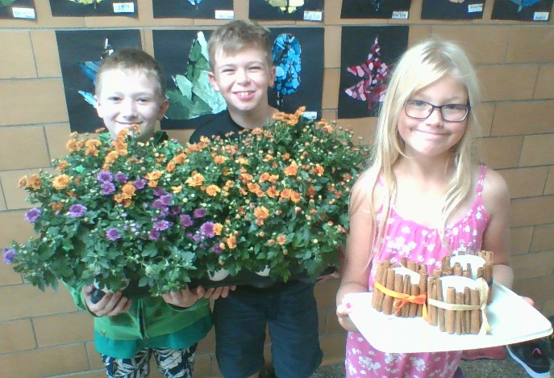
Note from Miss Deruytter’s class:

Miss Deruytter’s Grades 4 and 5 students will be selling Fall Centrepieces as a fundraiser for their classroom horticultural activities. The cost is $9.00 for a full centrepiece. $5 for a mum, and $4.50 for a candle. Sales began Friday, September 28th. If you are interested in purchasing any items, please send in cash with your child. Thank you.

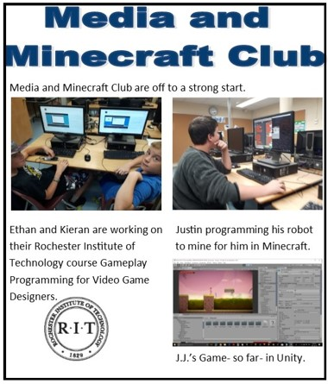
Terry Fox Run
On Friday, September 28th, the school participated in the Terry Fox Run. The whole school walked and ran around the block to raise money for the Terry Fox Foundation. We also had an assembly where students watched a video about Terry Fox and the history of his run. The school raised over $ 370. Great work everyone. Thanks to Ms. Marshall for all of her work in organizing the event.
Three – Pitch Tournament
Last Wednesday Mr. Eisenbach took the baseball team to Paris for their Tournament. The team went 1-2 with the scores being very close. Thanks to Mr. Eisenbach and Ms. Smith-Douglas for coaching the team!
Primary Cross Country
The primary division has been participating in Cross Country running around the back yards at the end of the day. With there being many warm days at the end of September, the students were able to get out many times and go for a run. Thanks to Mr. Murray for organizing the run!

