Project | SEARCH Partners



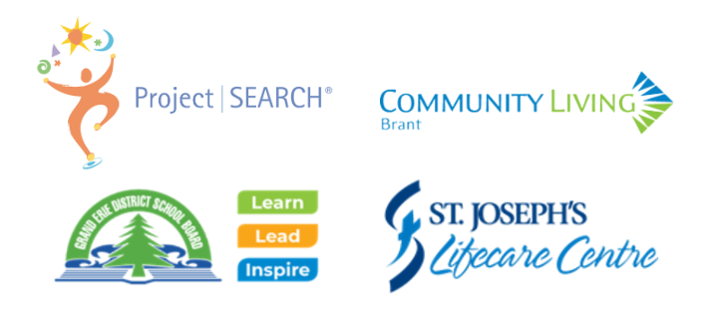

Student Application Package
2024 - 2025 School Year

Due Date: Friday, April 5th, 2024

Purpose:
- To outline the skill set of the Student Applicant.
- To allow the Selection Committee (Project SEARCH Partners) to properly assess each applicant’s skills, abilities, and background.
- To select applicants who will be successful in the Project SEARCH program and reach the outcome of competitive employment following graduation.

Surname |  | Given Name & Preferred Name
D.O.B.: dd/mm/yyyy | School: |  | Grade/Program | Preferred Pronouns
Criteria for Application - applicant must meet all of the following criteria:
Must be 18 years of age or older on the day the Project SEARCH program starts
Applicant is in their final year of high school and plans to enter the employment field and not return to secondary school
Have a diagnosis of intellectual and/or developmental disability (MID, DD, ASD)
Must be able to communicate effectively with reasonable accommodations
Have means of transportation, personal vehicle or public transit**
Must be able and willing to participate in the regular program hours which is the normal school day, five days per week, for the full school year
Have a desire to increase employability skills through classroom instruction and hands-on experience in an employment setting
Can independently regulates behaviour and demonstrate social skills
Can be independent with personal care and hygiene
Willing to comply with host site requirements if the applicant is successful (i.e.- Full Covid vaccination, proof of two step Tuberculosis skin test, completion of a Vulnerable Sector Police Check, Flu vaccination)
Completion of Developmental Services Ontario (DSO) Intake Form
** transportation can be provided under some circumstances (i.e.- rural residential address)

Application Package must include all of the following items:

Project | SEARCH Applicant Selection Rubric (Appendix A) completed by current teacher and/or classroom staff.
Student Voice – letter, visual or digital presentation to express why the student wants to participate in Project Search and what they hope to gain from the experience. Guiding Questions found on page 3 of this package.
Consent for Disclosure and Collection of Information Form (Appendix B). Page 4 of this package.
Prior Work Experience Form (Appendix D) and Reference Pages 5-6 of this package.

Signature of Principal |  |  | Date
Principal Name:

Selection Process for Project SEARCH Grand Erie

- Applicants must meet all Project SEARCH criteria, found on page 2 of this package.
- Completed Application must be submitted to the Specialized Services Program Coordinator, lindsay.sheppard@granderie.ca, by the school LRT on or before Friday, April 5th, 2024.
- Completion of application does not guarantee the applicant placement in the program.
- Program Coordinator will not accept incomplete application packages. Incomplete packages will be returned to sending LRT.
- Applicants must attend a Skills Assessment & Interview session prior to final selection.
- Successful applicants will be notified by the Special Education Program Coordinator.
- Successful applicants will review and sign the Project Search Student Contract prior to the start of the work placement.
- Successful applicants must pass a Vulnerable Sector Police Check, provide proof of two step Tuberculosis skin test, and full Covid vaccinations as well as any other mandatory screenings as per workplace regulations prior to the start of the work placement.

Guiding Questions for Student Voice

Why do you want to participate in Project SEARCH?
Please submit your answer in whatever format is best for you – written (or scribed) response, video recording, digital storytelling/slide show (such as PowerPoint or Canva), or another format of your choosing.

Note: It is expected that applicants might receive support with this portion of the application, but please ensure that it is the student’s voice represented here (support from parents and/or school staff can be expressed in the Applicant Selection Rubric).

The following Guiding Questions could be used to help frame your response to the question above.

Tell us about...
- Why you want to have a job after high school?
- Describe a skill you want to learn that you might need for a job?
- What you think it feels like to have a job?
- If you like to learn in a hands-on way?
- If you like to work with people?
- If you want to learn how to work with other people?
- If you want to learn skills in a different environment (not in a classroom), and why?
- Why you want to try out different jobs to see what you like or what you are good at?
- If you like to learn new things or work with new people?
- Why it is important to you to meet other students your age with similar interests in learning job skills?
- Why it is important to you to create a plan for what you are going to do after high school?


Appendix B
CONSENT FOR DISCLOSURE AND COLLECTION OF INFORMATION

Name of Student |  | Date of Birth: dd/mm/yyyy
School:

I/We the undersigned, authorize the Grand Erie District School Board to:

Release the following information for myself or my child;
- IEP (Individual Education Plan)
- Project SEARCH Student Application Package
- Project SEARCH Student Contract

To | Identified contact(s) of any of our Project SEARCH partners (as featured on the cover page of the application package)
For use by such officers or employees of the Board who may need the personal information in the performance of their duties or for the purpose of complying with the Act of the Legislature or in Act of Parliament or a Law Enforcement Agency in Canada to aid a current or potential investigation undertaken with a view to a law enforcement proceeding

Signatures
Parent/Guardian:
Student (if applicable)
Witnessed by:
Date:

This form will be kept as a record under the authority of the Education Act, R.S.O., 1990, c.E.2 AND the Municipal Freedom of Information and Protection of Privacy Act and will be used for the purposes of the education of students. This form will be retained in the student’s Ontario School Record and/or relevant Student Support Services Partner/Student files. Questions about the collection should be directed to the Special Education Principal Leader (confirm Julie’s title) or Superintendent of Education – Special Education.

Filed in OSR
Retention: E+10 years (E = retirement of student)

Appendix D

Project | SEARCH Prior Work Experience Form

Please list the jobs (both paid and volunteer) that you may have done both in your school(s) and in the community. Leave blank if you don’t have any at this time.

Please list the jobs (both paid and volunteer) that you have done in your school(s) and in the community. Please check if the job was paid or volunteer.
☐ Paid  ☐ Volunteer | Location:
☐ Paid  ☐ Volunteer | Job Duties:
☐ Paid  ☐ Volunteer | Location:
☐ Paid  ☐ Volunteer | Job Duties:
☐ Paid  ☐ Volunteer | Location:
☐ Paid  ☐ Volunteer | Job Duties:
☐ Paid  ☐ Volunteer | Location:
☐ Paid  ☐ Volunteer | Job Duties:

References do not have to be related to work experience if no experience exists. Feel free to include staff from the school, close family members or trusted adult friends. Please ensure that you have their consent to be used as a reference.

References may be contacted by the Selection Committee.

Applicant’s References
Reference #1
Full Name:
Relationship to Applicant:
Phone Number:
Email Address:
Reference #2
Full Name:
Relationship to Applicant:
Phone Number:
Email Address:
Reference #3
Full Name:
Relationship to Applicant:
Phone Number:
Email Address:

Assistance
The person assisting the candidate to complete this Student Application Package is:
Name: |  |  | Title:
Organization:
Phone Number:
Email Address:
Signature

