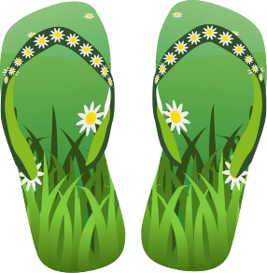

June News

Dear Parents,
Well this is it - the final newsletter from Room 3! Can you believe it? As I sit by the computer composing the last set of report cards, it makes me smile how much your children have grown this year, both academically and physically! All of a sudden they are looking like Grade 3 students! I would just like to thank all of you for your support this year. I certainly couldn’t have done it without you!
June is passing by very quickly. Our trip to Kanata Village is next Friday. Please ensure that your child has sunscreen they can reapply themselves, and a hat would also be a good idea. Fingers crossed for sun!
In language we are ending the year with our animal research projects. During this activity the students while have to work through the steps of research. First students will choose VIP’s (Very Important Points) for appearance, habitat, food, babies, and enemies, food, and interesting facts. In Room 3 we describe a VIP as being an interesting or cool fact. We use post it notes to select the 3 most important points because then we can move the post it if we happened to find an even more interesting VIP as we continue to read. After VIP’s have been chosen the students will write these facts in their own words, and then finally they will publish their project and share it with the class. The students will complete all the work at school, however if you wish to help your child find pictures that they want to use in their project they are certainly welcome to do so.
In math we are finishing up problem solving with time this week and moving onto probability on Monday. Although our time unit is complete, please continue to tell time with your child in real life situations. Students found telling the word times ‘quarter to’, ‘quarter after’, and ‘half past’ tricky, but digital times were done quite well. Our next unit is probability. Probability is the chance of an event occurring. We will talk about the chance of everyday events occurring, using the words likely, unlikely, for certain, and impossible. We will then work with spinners to see if we can create spinners that will spin a predicted outcome.
We have concluded our social studies unit comparing and contrasting different communities around the world, in terms of what they eat, where they live, the games they play, and the clothes they wear. The students have a very good understanding of the impact the distance from the equator has on meeting all of these needs. In science we are working on our last unit on life systems. We will be talking about the life cycles of several different animals, as well as sorting animals into different groups based on their characteristics. We will also talk about how humans and animals affect each other and their habitat, as well as the importance of living together in harmony.

Well I think that is all the news from Room 3. If I don’t see you before, please have a wonderfully relaxing summer. Please don’t forget to read with your child a little each day to maintain all of the wonderful progress that your child has made throughout this year. They can also practice writing by helping you write To Do lists, groceries lists, or emails/texts to friends and family. They won’t even know that they are really practicing ‘school stuff’ during their summer vacation!
Sincerely, Suzie Johnson

